A Colonial Fort in Coastal Maine
In mid-coast Maine there is a peninsula, a finger-like projection of land thrusting out to sea like many another along the state’s indented coast. What makes this area special, lying as it does between the Pemaquid River to the west and Muscongus Bay on the east, is its rich Colonial history. For just past the entrance to the river from Johns Bay on the Gulf of Maine, there lies a smaller spit of land trending north from Pemaquid Harbor. And there along the waterside, only a half-mile or one-minute drive from the Sherwood Forest Campsite and Cabins, lies the site of Colonial Pemaquid; upon which rests, to this day, the remains of the 17th-century Fort Henry. It is well worth a visit.
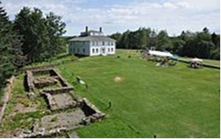 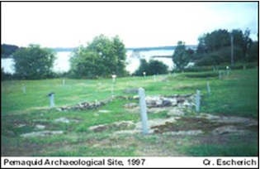
Technically this location, a registered National Landmark and Historic Place owned by the State of Maine, is located in the village of New Harbor within the town of Bristol, ME. But history buffs know it better as Pemaquid; a site once besieged and fought over during the early colonial conflict known as King William’s War (1688-97). The Siege of Pemaquid took place in 1689; but today the ground is an archaeological site, helped kept preserved by The Friends of Colonial Pemaquid; an all-volunteer non-profit association established in the fall of 1993.
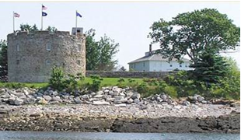
Now known as Colonial Pemaquid State Historic Site, the site includes the archaeological excavations of 17th- and 18th-century village buildings, a museum with excavated artifacts found on the site, including musket balls, coins, pottery and early hardware, and an early 20th-century reconstruction of the late 17th-century fort.
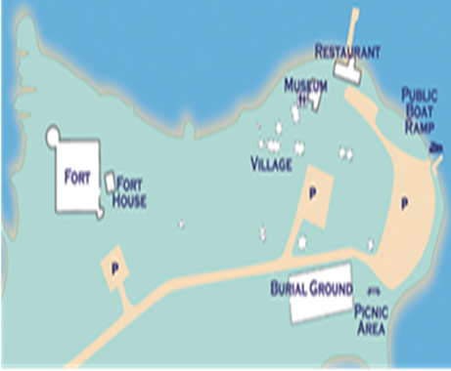
Home to Native Americans dating back at least one thousand years, Colonial Pemaquid later became the site of a very early English outpost and fishing station.
Today, Colonial Pemaquid is a State Historic Site owned and managed by the Division of Parks and Public Lands, part of the Maine Department of Agriculture, Conservation and Forestry. The Friends of Colonial Pemaquid is a non-profit organization that provides important assistance to the state in caring for and interpreting this site.
Fort William Henry - Built on the site of two previous forts, the stone structure here was built in 1907 as part of the 300th Anniversary of Colonial Pemaquid. It is a replica of the 1692 Fort William Henry, the third fort constructed on this site. The tower of the fort contains interpretive panels and artifact exhibits as well as a beautiful view of the area from the roof.
Fort House - This restored Federal-style home dates to 1790 and contains a research library, archaeology lab, interpretive information and artifact storage from the many archaeological digs that have been conducted at Pemaquid.
Village - This collection of stone building foundations reveals the locations and size of structures from various periods of the village's history.
Burial Ground - Gravestones in this burial ground date back well into the early 1700s and this is likely the site of burials for settlers dating back to the original British arrival in the 1620s.
Museum- The museum houses dozens of exhibits on the history of Pemaquid from ancient Native American life here through the colonial period. It also includes a large diorama of the Pemaquid village. The museum is open and staffed from Memorial Day weekend through September 1 every day from 9-5. Admission is part of the Colonial Pemaquid day use fee -- which includes the Fort, Fort House and Museum. Adults over 65 may enter free of charge. The phone number is 207-677-2423.
The Angel Gabriel was a galleon that was destroyed by a hurricane while anchored at Pemaquid in 1635. In 2010, descendants of the survivors dedicated a bronze plaque at the site commemorating the wreck.
A Gift Shop operated by the Friends of Colonial Pemaquid offers history-related items to visitors. It is located in the Fort House. Colonial Pemaquid is managed with the help and support of the Friends of Colonial Pemaquid. To learn about the Friends, visit their Web site at: http://www.friendsofcolonialpemaquid
The official Statement of Significance as of designation in April 12, 1993, reads:
“This site of a fortified village, founded by English settlers around 1625, marked the northeastern frontier of New England. Pemaquid was one of the first and most important centers of intercultural relations between Native Americans and English colonists in present-day Maine. To date, archaeologists have unearthed more than 75,000 artifacts from the foundations of 17 contributing building sites, yielding much information about life in an early American community.”
A stroll across the grounds shows a commanding view of Pemaquid Harbor and Johns Bay southward and the Pemaquid River north and eastward, even from ground level. Imagine the view from the top of the fort in its heyday!
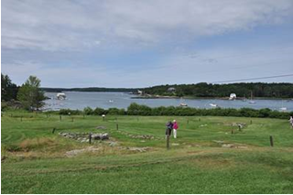
History:
Fort William Henry was the largest fort in New England. It was originally built in 1692 but destroyed four years later by New France in the Siege of Pemaquid (1696). The fort was rebuilt in 1908. The fort was added to the National Register of Historic Places on December 1, 1969. Fort William Henry is now operated as a museum about the fort's history.
The first fort on this site was Abraham Shurte's Fort (1630 - 1633), a palisaded trading post that was burned down by pirates under Dixie Bull. The next fort built was Fort Pemaquid was then built (1633 - 1676), which was destroyed in King Philip's War. The third fort was Fort Charles (1677 - 1689).
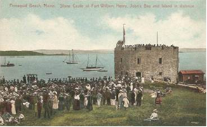 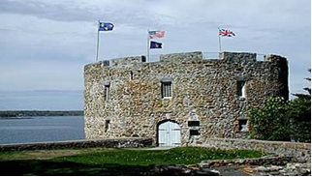
During King William’s War, in August 1689, Jean-Vincent d'Abbadie de Saint-Castin and Father Louis-Pierre Thury led an Abenaki war party that captured and destroyed the fort at Pemaquid (in present-day Bristol, Maine). The fall of Pemaquid was a significant setback to the English. It pushed the frontier back to Casco (Falmouth), Maine.
The Siege of Pemaquid (August 2–3, 1689) was a successful attack by a large band of Abenaki Indians on the English fort at Pemaquid, Fort Charles, then the easternmost outpost of colonial Massachusetts (present-day Bristol, Maine). The French-Abenaki attack was led by Jean-Vincent d'Abbadie de Saint-Castin and Father Louis-Pierre Thury and Chief Moxus. The fall of Pemaquid was a significant setback to the English. It pushed the frontier back to Casco (Falmouth), Maine.
The fort at Pemaquid was under the command of Lieutenant James Weems and was significantly under strength after most of its garrison had deserted in the wake of the revolt and overthrow of Governor Andros at Boston earlier in the year. The complement of soldiers was reduced to thirty and many of these were in a mutinous state. The Indian force surrounded the fort, capturing or killing most of the settlers in the countryside about the fort. Lieutenant Weems provided a defense for a day, but after taking heavy casualties (Weems and 23 of the garrison having been wounded), he surrendered. The Abenaki allowed Weems and his men to return to Boston. On August 4, the Abenaki burned the fort and the nearby settlement of Jamestown.
The fort at Pemaquid was rebuilt in stone in 1692–93 and renamed Fort William Henry. Construction of the fort was ordered by Massachusetts Governor Sir William Phips and cost £20,000 to build. The Massachusetts government used one third of its budget to build the fort. The English colonial militia leader Benjamin Church assisted in the construction. The fort was built with walls that were 10 to 22 feet in height and a stone bastion which was 29 feet in height. The fort was armed with 20 cannon and a garrison of 60 soldiers.
Four years later d'Abbadie de Saint-Castin and the Wabanaki Confederacy captured it again. The English regained their authority over the region by building Fort William Henry. The English built Fort William Henry as a fortress to protect the northern boundary of New England. (Castine, Maine was an Acadian settlement, which marked the southern boundary of Acadia.)

The fort was attacked by a combined force of French and Native Americans in the Siege of Pemaquid (1696). For all its apparent strength, Fort William Henry did not last. Native people, upset at their treatment by the English, united with the French to attack the fort in 1696. This fort, which had seemed so strong, proved to be weak. Mortar used to build the stone walls was of poor quality and the fort's interior buildings could not stand bomb attack. The garrisons' water supply lay outside the fort walls. His garrison outnumbered, Captain Pasco Chubb finally surrendered. With the fall of Fort William Henry, the English abandoned Pemaquid once again. The English were forced to surrender the fort and abandon the Pemaquid area. Benjamin Church avenged the destruction of the fort with the Raid on Chignecto (1696) in Acadia. After Father Rale's War, Colonel David Dunbar, Surveyor-General of the King's Woods, rebuilt the fort in 1729-1730, renaming it Fort Frederick. During King Georges War, Fort Frederick withstood two attacks in 1747. [9] During the French and Indian War, the fort was decommissioned in 1759 after a new Fort Frederick was built on the St. John River the previous year.
Getting Here:
Whether heading northeast from Portland or south from Augusta, head for the town of Newcastle along State Route 1, about midway between Brunswick and Rockland.
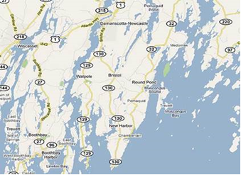 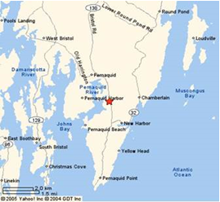

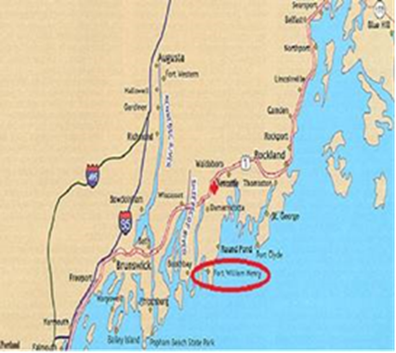
From Newcastle (Drive: 13.4 miles, 22 min.):
1. Head southeast on Academy Hill toward High St., 0.1 mi
2. Continue onto Main St., 0.4 mi
3. Turn right onto ME-129 S/Bristol Rd., 2.9 mi
4. Slight left onto ME-130 S, 8.5 mi
5. Turn right onto Huddle Rd., 1.1 mi
6. Turn right onto Snowball Hill, 240 ft
7. Take the 1st right onto Colonial Pemaquid Rd
Destination will be on the left

